What’s Up, St. Paul’s?
Greetings Friends: Welcome to fall - such a beautiful time of year!
As outlined in our first newsletter, we wanted to provide additional details about the hopes and goals of our new ministries. These ministries were designed to help us work together, using the efforts outlined in our Vision Statements, to become the church we believe God yearns for us to be.
The first ministry we will consider is a new one - our Stewardship Ministry.

‘Stewardship’ is a word we often talk about, but we realized we didn’t entirely know what it means in the life of a church.
As we gathered as a new team, we reached out to our National Church, as they have a department that focuses on stewardship. We spoke with Karen Plater, Associate Secretary of Stewardship at The Presbyterian Church in Canada. After our conversation, Karen asked if we would consider joining her in attending the annual Stewardship Conference offered by the Presbyterian Church (USA). She said this was an excellent conference and she liked to take a group of people from congregations across Canada to attend each year. She offered to pay our expenses to participate - an opportunity which felt like a God-given gift.
This year, the conference was held in New Orleans, Louisiana, and it became clear that it was no coincidence as to why. It was exactly 20 years ago that New Orleans was devastated by the powerful Hurricane Katrina.
During the week, we heard many stories of churches facing similar challenges that St. Paul’s faces today. Some were large churches, while others quite small. Yet, we were inspired by stories of rebirth and renewal, and the realization that God was with them through it all.
One pastor shared her story of leading their church in New Orleans where 90% of its members lost their homes. Two members perished during the storm. At times, with emotions still raw 20 years later, she shared stories of the difficulties, but also stories of community, of 100,000 volunteers coming from around the world to do whatever they could to care for those facing such devastation. She said, despite the darkness, they felt God’s light, hope and strength as they worked to rebuild.
As we listened to this story, and as we look to our future, it somehow made the challenges that St. Paul’s faces seem less daunting. We believe that God wanted us to hear these stories of faith, hope and resilience, and that in the darkest of trials, God was there.
We also heard messages of generosity, like the words the apostle Paul spoke in 2 Corinthians 9:7:
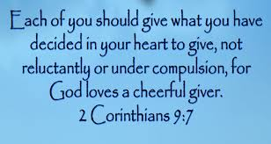

We were reminded that Stewardship is not simply about money. It is how we take care of the resources that God has given us - our time, our financial gifts, our building, as well as our spiritual gifts and passions. All these come from God and are to be shared for the common good:
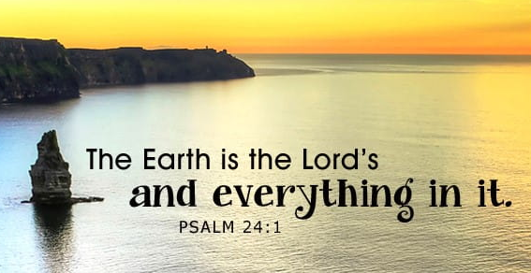
God wants us to be generous. Often when we reach out and bless others, we are greatly blessed in return.
This is one of our Vision Statements:
#4. People joyfully and generously serve according to the gifts God has given them.

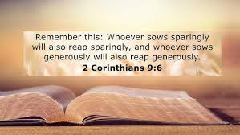

We have read many stories in the Bible where God has done amazing things with people who gave what they could. We encourage you reflect on the miraculous stories of The Widow’s Olive Oil (2 Kings 4:1-7) and Feeding the 5,000 (John 6: 1-14).
As we look ahead, the Stewardship Team will consider ways to help us reflect on a spirit of generosity, and what this could mean for the life and ministries of St. Paul’s. To help us focus on this, we have created a Stewardship Theme:
When we place our gifts in God’s hands,
God does remarkable things.

Generosity is a very personal thing, and we believe this comes down to our faith. When we truly believe God can do more than we can ever ask or imagine, the possibilities of what we can do together are amazing to think about.
We live in a hurting world that is aching for a message of hope. Perhaps God wants St. Paul’s to be an answer to prayers in our community, if we have the courage to step out in faith, and be generous with our time, talents and gifts - gifts that God has given each one of us.
The current members of the Stewardship Team are Pastor Al, Josh Vanderstelt, Becky Tunks and Kathy Smit. If you have any questions or concerns or have a heart for generosity and dream about building strength for our future, the Stewardship Team would love to hear from you.
We are ‘stewards’ of the Kingdom, and we are meant to make it visible, bringing hope and healing to the world. May we pray that St. Paul’s has not yet seen its best days in doing the work of our Lord.
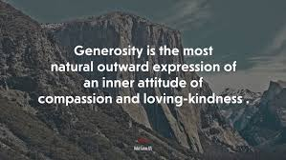

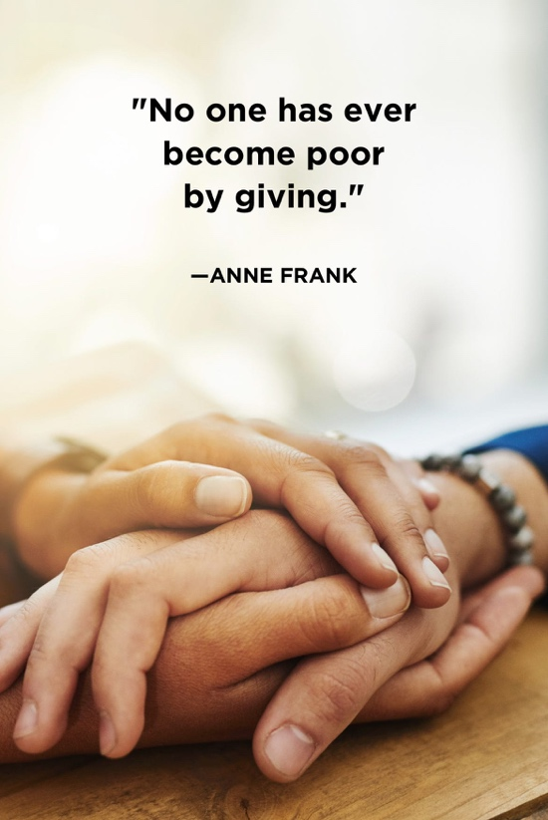

Calendar -
November 7th - Roast Pork Dinner
December 6th - Christmas Market

Did You Know?
St. Paul’s participates in the community ‘Meals on Wheels’ program each month. This ensures those in the community who need a nutritious meal can receive it. If you would like to help with this outreach program, in delivering these meals, we’d love to hear from you. You can contact Sue Harrison at 519-852-0458.

We are So Thankful for:
- The members of our Tech Team. These ‘unsung heroes’ ensure we can live stream our service, with the proper audio for everyone to hear, every week. We give thanks for Josh Brouwer, Zach Brouwer, Brian Hawkins, Cooper Juett, Leland Kernahan, Jaden Rosefield and Peter Rosefield for sharing their gifts in this way this year.
- Shannon Carlyle who has stepped away from leadership in the Sunday School after 12 years; some of these years were through the pandemic. Thank you, Shannon, for sharing your gifts with our children. You may never know the positive impact that you have made in their lives.
- Harold and Nancy Matthews who demonstrated their gifts of gracious hospitality in hosting our ‘Welcome Back Picnic” again this fall.

